|  |
| --- |
| PS2Win |
| Weekly Report |
| Keep Your Time |

|  |
| --- |
| Filipe  16-03-2013 |

**Team Members:**

Carla Machado

David João

Filipe Brandão

João Girão

João Martins

Mário Oliveira

Rui Ganhoto

**Week 4**, 11th of March to 18th of March

Content

1. Week Activities 1

1.1. Work Executed 1

1.2. Work Analyses 1

1.3. Achievements 1

2. Impediments 2

3. Plans For Next Week 2

4. Progress 2

4.1. Earned value and/or Gantt Image 2

4.2. Effort by task 3

4.3. Individual effort 3

5. Individual log 4

**Images**

Figure 1 - Earned Value 2

Figure 2 - Effort by task type 3

Figure 3 - Individual Effort 3

**Tables**

Table 1: List of Contributors ii

Table 2: Version history ii

Table 3: Log of individual effort 4

|  |  |  |  |
| --- | --- | --- | --- |
| **Authors and Contributors** | | | |
| **Date** | **Name** | **Contacts** | **Contribution** |
| 16-03-2013 | Carla Machado | a21170460@alunos.isec.pt | Author |
| 09-03-2013 | Filipe Brandão | a21180276@alunos.isec.pt | Author |
| 18-03-2013 | Mário Oliveira | a21170292@alunos.isec.pt | Contributor |
| 18-03-2013 | Rui Ganhoto | a21170262@alunos.isec.pt | Contributor |
| 18-03-2013 | David Silva | a21170222@alunos.isec.pt | Contributor |
|  |  |  |  |
|  |  |  |  |

Table 1: List of Contributors

|  |  |  |  |  |  |
| --- | --- | --- | --- | --- | --- |
| **Revision History** | | | | | |
| **Date** | **Description** | **Author** | **Version** | **Approvers** | **State** |
| 16-03-2013 | Creation of first draft | Carla Machado | 0.1 |  | Draft |
| 17-03-2013 | Draft continuation | Filipe Brandão | 0.2 |  | Draft |
| 17-03-2013 | Small updated, adding information. | Carla Machado | 0.3 |  | Draft |
| 17-03-2013 | Changing State | Filipe Brandão | 0.3 |  | Ready for revision. |
| 18-03-2013 | Document reviewed | Mário Oliveira | 0.3 |  | Ready for revision |
| 18-03-2013 | Changing state | Filipe Brandão | 0.3 |  | Ready for approval |
| 18-03-2013 | Approval |  | 0.3 | Rui Ganhoto | Ready for approval |
| 18-03-2013 | Approval |  | 0.3 | David Silva | Ready for approval |
| 18-03-2013 | Changing State | Filipe Brandão | 1.0 |  | Baselined |
|  |  |  |  |  |  |
|  |  |  |  |  |  |
|  |  |  |  |  |  |

Table 2: Version history

# Week Activities

# Work Executed

* Correction of Planning Project Process
* Review Process started
* Continuation Requirements Analysis Process
* Vision and Scope approved
* Continuation of Project Assessment and Control Process
* Dashboard updated with project, client and team name

# Work Analyses

Overall the work scheduled for the week was accomplished although if the team had managed to be more efficient some tasks could be further along as well as additional tasks could now be in progress.

The Earned Value generated some questions and discussions as to what process it should belong to. Despite the doubts and the difficulty in reaching a decision one was made in order to be able to advance the work and stop spending time discussing the issue.

In spite of the changes to the Project Planning Process the process is finished and ready for approval.

During the creation of the Review Process some doubts came up but were overcome enabling the evolution of the process to the state “Ready for Revision”.

The Requirements Analysis Process also suffered some difficulties namely in the measures definition and deciding what measures could be useful. The process is now “Ready for Approval”.

# Achievements

* Vision & Scope document is baselined.
* Planning Project Process is ready for revision.
* Requirements Analysis Process is ready for approval.
* Review Process is ready for revision.

# Impediments

This week there were some difficulties and impediments such as

* Definition of measures in the Requirements Analysis Process
* Definitions of the various activities of the Project Assessment and Control Process
  + Research on the process wasn’t very helpful
* It’s hard to convert Earned Value worksheets to Google Docs and might take too much time and effort

# Plans For Next Week

* Approve Planning Project Process
  + If approved start project planning and definition of Quality plan
* Approve Requirements Analysis Process
* Approve Review Process
* Ready the Project Assessment and Control Process for review
* Start Verification & Validation Process

# Progress

# Earned value and/or Gantt Image

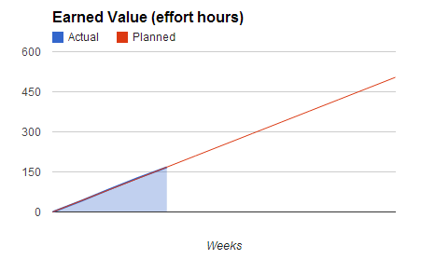

Figure 1 - Earned Value

Actual = 167.5

Planned = 168

# Effort by task

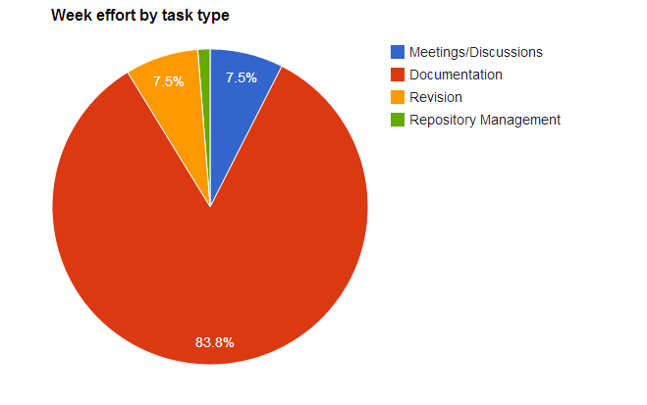

Figure - Effort by task type

# Individual effort

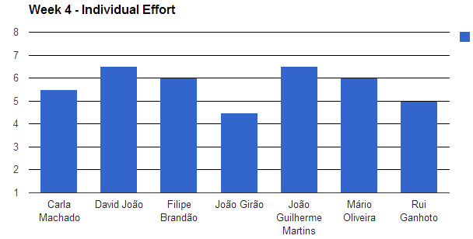

Figure - Individual Effort

|  |  |
| --- | --- |
| **Name** | **Effort(hours)** |
| Carla Machado | 5.5 |
| David João | 6.5 |
| Filipe Brandão | 6 |
| João Girão | 4.5 |
| João Martins | 6.5 |
| Mário Oliveira | 6 |
| Rui Ganhoto | 5 |

Table 3: Log of individual effort

# Individual log

**Carla Machado - Tasks done:**

* Requirements analysis process
* Reviews
* Discussions
* Weekly Report

**David João - Tasks done:**

* Writing Project Assessment and Control
* Discussions
* Approval of vision and scope

**Filipe Brandão - Tasks done:**

* Changes to Project Planning Process.
* Producing Review Process
* Discussions
* Weekly report.
* Template for Revision Report
* Approved Requirements Process

**João Girão - Tasks done:**

* Requirement Analysis Process
* Discussions
* Vision and Scope Baselined

**João Martins - Tasks done:**

* Studied examples of other processes of Project Planning
* Writing minute of the third reunion
* Approving Documents
* Changes in the Project Planning Process
* Several discussions

**Mário Oliveira - Tasks done:**

* Creating draft for the Review Process
* Next meeting agenda
* Update repository
* Revision of Project Planning process

**Rui Ganhoto - Tasks done:**

* Revision of the last meeting agenda
* Writing Project Assessment and Control
* Discussions
* Requirement Analysis Process Review